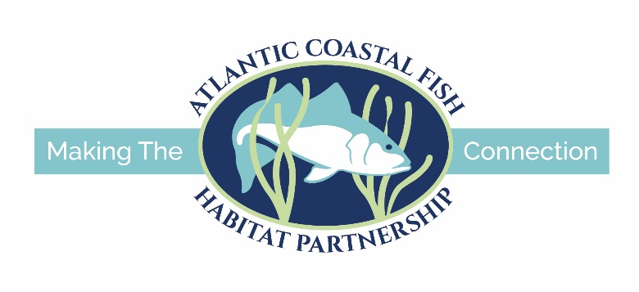

**APPLICATION INSTRUCTIONS**

**for**

**FY2025 Atlantic Coastal Fish Habitat Partnership Funding**

The Atlantic Coastal Fish Habitat Partnership (ACFHP) is requesting project applications for funding to restore and conserve habitat necessary to support coastal, estuarine dependent, and diadromous fish species. Federal funding available through the National Fish Habitat Partnership (NFHP) program will be used to support the top ranked proposals.

America’s Conservation Enhancement (ACE) Act was passed by Congress and signed by the President on October 30, 2020. The legislation made significant changes to project eligibility requirements for this funding opportunity; this is reflected in the requirements described below. The ACE Act places an emphasis on restoration efforts that will improve recreational fishing opportunities and public use of resources. Improvements in public access as a component of projects are also encouraged.

Specific requirements include:

• Requested NFHP grant funds must be **matched** **1:1 with non-federal funds**. Non-federal match can include cash and/or in-kind labor, materials, or equipment, if there are no federal ties to those funds. State agency funds can be used for the non-federal match if labor and/or materials are not being matched to another federal grant and do not have a federal origin (e.g., WSFR). State agency funds that are used to match other federal grants would not be eligible as match.

• All NFHP funded projects must include an outreach/education component.

• Monitoring and evaluation measures must be included as part of the project application but should not make up a significant portion of the funding request.

• The ACE Act included special considerations for Indian Tribes. Please contact the ACFHP Chair for more details, if applicable.

• The ACE Act allows a state, local government, or other non-federal entity to receive NFHP funds for the acquisition of real property from willing sellers if the acquisition ensures public access for fish and wildlife-dependent recreation or contributes to a scientifically based, direct enhancement to the health of fish and fish populations as determined by the NFHP Board. All real property acquisition projects funded with NFHP funds must be approved by the state agency responsible for sovereign land ownership and management in the state in which the project is occurring. If you are applying for acquisition funding, contact the ACFHP Chair for more details.

These funds can only be used for land acquisition or on-the-ground habitat conservation and restoration projects and associated design and monitoring activities. **They may not be used for projects required as part of a regulatory action. At this time, ACFHP is not soliciting applications for research projects that do not include on-the-ground habitat restoration.** Construction phase projects are expected to have received all necessary permits and meet all environmental compliance requirements. All projects are expected to be completed within 18 months of receipt of funding.

**Available funding:** In past funding cycles, we typically supported 2-4 projects for a total of $90,000 – $250,000 annually. We do not have a maximum request amount. This is a very competitive process and the amount of funding applied for has always exceeded the amount available. As noted above, successful proposals must demonstrate a minimum 1:1 non-federal match. Once the requested NFHP grant funds are matched with non-federal funds/in-kind, an unlimited amount of federal and non-federal contributions to the project are allowed. ACFHP gives special consideration to projects with more than the minimum match.

**Timeline:** Applicants will be notified of their projects’ funding status as that information becomes available. Funding decisions will not be made until a federal budget is passed for FY2025. FY2025 starts on October 1, 2024. Applicants should not expect to hear anything until at least the last quarter of 2024. The total amount available to fund projects is unknown at this time.

**Note regarding federal funds**: NFHP funds are federal funds, administered through the U.S. Fish and Wildlife Service (USFWS). All organizations that receive NFHP funding are required to complete all requirements for federal grants, including registration on the federal System for Award Management (SAM.org), Automated Standard Application for Payments (ASAP), Grants Solutions grant management system, and provide interim and annual reports to the USFWS and ACFHP. NFHP funds are processed through a grant agreement completed through the USFWS Regional Offices or local Fish and Wildlife Conservation Office (FWCO). Grants are paid on a reimbursable basis and cannot cover pre-award costs. Recipients and sub-recipients of federal grants must comply with the requirements of the National Environmental Policy Act (NEPA), Section 7 of the Endangered Species Act (ESA), and Section 106 of the National Historic Preservation Act (NHPA). Environmental compliance documents must be provided to USFWS before any potentially impactful work related to the award can begin. If environmental compliance documents are not provided prior to the execution of the grant agreement, the award will be issued conditionally. In that case, the Recipient must not begin any potentially impactful work before the USFWS has notified them in writing that such work can begin. More detailed information from the USFWS about federal grant processes is available [here](https://www.atlanticfishhabitat.org/wp-content/uploads/2021/11/2021-10-27_NFHP-Application-and-Award-Requirements.pdf)**.**

Applications will be reviewed and ranked by ACFHP based on their potential to help the partnership meet its conservation objectives described in its [Conservation Strategic Plan](https://www.atlanticfishhabitat.org/wp-content/uploads/2023/09/ACFHPStrategicPlan_2022_2026.pdf). For fish passage projects, you must submit separate proposals for each barrier (e.g., if you are removing a dam and fixing a culvert in the same river, you must submit two separate proposals).

Website: [FY2025 Atlantic Coastal Fish Habitat Partnership Funding Cycle – Atlantic Coastal Fish Habitat Partnership (atlanticfishhabitat.org)](https://www.atlanticfishhabitat.org/fy2025-atlantic-coastal-fish-habitat-partnership-funding-cycle/)

The following is required to apply:

1. **Application Form**: An online application form is available at: <https://fs3.formsite.com/pim0X7/ghgaaudish/index>. The following pages of this document provide guidance for completing the application.
2. **Photographs and Photograph Release Form**: Release forms are available on the ACFHP website at: [FY2025 Atlantic Coastal Fish Habitat Partnership Funding Cycle – Atlantic Coastal Fish Habitat Partnership (atlanticfishhabitat.org)](https://www.atlanticfishhabitat.org/fy2025-atlantic-coastal-fish-habitat-partnership-funding-cycle/).

Forms should be signed, scanned, and emailed with your application.

The following is recommended but not required:

1. **Copies of any permit letters received to date from authorizing agencies.**
2. **Letter of Support** – Obtain a letter of support from the appropriate state natural resource agency or other pertinent supporters of your project. This letter can be from an ACFHP state contact. Contact information for ACFHP members can be found at: <https://www.atlanticfishhabitat.org/our-team/>.

**Applications must be received by 5:00 pm Eastern time on Wednesday, January 31st, 2024.** Any supplemental documents for the application that cannot be uploaded in the online form should be emailed to the ACFHP Director, Simen Kaalstad, at [skaalstad@asmfc.org](mailto:skaalstad@asmfc.org).

To view the criteria that will be used to evaluate project applications, please click here:[FY25 Evaluation Criteria](https://www.atlanticfishhabitat.org/wp-content/uploads/2023/10/FY25-Evaluation-Criteria.xlsx).

**Incomplete applications will not be considered.**

By submitting an application, you agree to use the ACFHP logo on your project outreach materials, share project reports, monitoring results, and before and after photos with ACFHP, as well as agree to ACFHP featuring your project on its [website](https://www.atlanticfishhabitat.org/). To learn about our funded projects, sign up for our [newsletter](https://lp.constantcontactpages.com/su/IOUOE8c).

For questions, please contact:

Kent Smith, ACFHP Chair

Phone: (850) 617-9504

Email: [kent.smith@myfwc.com](mailto:kent.smith@myfwc.com)

Jessica Coakley, ACFHP Vice Chair

Phone: (302) 526-5252

Email: [jcoakley@mafmc.org](mailto:jcoakley@mafmc.org)

Simen Kaalstad, ACFHP Director

Phone: (703) 842-0743

Email: skaalstad@asmfc.org

**APPLICATION GUIDANCE**

**Please do not submit this section as your application.** This section is provided to assist applicants in preparing a complete online application. It provides instructions and guidance for each of the items on the online application form ([ACFHP FY25 Project Application Form (formsite.com)](https://fs3.formsite.com/pim0X7/ghgaaudish/index)). The photograph release form can be found on the ACFHP website ([FY2025 Atlantic Coastal Fish Habitat Partnership Funding Cycle (atlanticfishhabitat.org)](https://www.atlanticfishhabitat.org/fy2025-atlantic-coastal-fish-habitat-partnership-funding-cycle/))

**\*Applicant Information**

Name of organization

Executive Director or the person that should receive all contractual information for signature

Address of Organization

Phone Number and Email

**\*Project Contact**

Lead Project Officer and Title (if different from above)

Affiliation

Phone (if different from above)

Email (if different from above)

Alternate contacts

Qualifications (include a brief abstract of relevant qualifications for the project lead and most important team members)

**General Project Information**

*Project Title

The title must be 100 characters or less and contain the initials NFHP as well as the type of project, body of water, city, and state (ex. SAV Restoration, Peconic Estuary, Suffolk County, NY NFHP).

*Project Location(State, County, City, Congressional District)

To find congressional districts, please visit: <https://www.census.gov/mycd/>

*Project Eligibility(please answer ‘yes’ or ‘no’ to the following)**:**

If you answer ‘yes’ to any of these questions, the project is ineligible for funding.

Are the actions proposed mandated by a regulatory program, court order, or decree?

Will any amount of the requested funds be applied to previous expenditures?

Will the requested funds be used for realty costs associated with the project?

Will the requested funds be used for operation or maintenance of facilities?

Is the project primarily a research study?

Will the requested funds be used for incentive payments (Annual payments to encourage participation (e.g. some NRCS Farm Bill programs))?

*Funding being sought for: __Design, __Planning, __ Construction, __Monitoring, __Outreach, __Land acquisition

*Have you been working with a U.S. Fish and Wildlife Service contact on this project? If yes, please provide the following, if available:

Date coordination began and Service involvement

Please check the box below to indicate the level of Service involvement in your project

__ process grant/coop. agreement __ assist with permit applications

__ assist with project design __ provide heavy equipment operators

__ provide engineer plans __ pre- and post- project monitoring

FIS Database Activity Number (obtained from Service contact):

Service Sponsoring Office:

Name of Service contact:

Letter or email of support from Service contact:

*Project description (max words: 100)

Provide a short summary that conveys an understanding of what the project involves and will accomplish. Please briefly describe the following: location, need for the project, purpose, goals, objectives, phase of the project to be completed, who will do the work, and who owns the land.

Statement of need

Please briefly describe the need for the project

*Funding amount requested

Funding amount requested from ACFHP, through this application.

**Project Design, Methods, and Outreach**

*Project Category

Select one primary category for the project

*Project Methods and Approach

Brief description the activities or methods used to achieve objectives of the project

*Monitoring and Evaluation Plan

Brief summary of monitoring and evaluation plan. If available, include information on timeline for monitoring and/or evaluation.

Climate change considerations

Does this project mitigate the impacts of climate change? If so, how?

Results dissemination

How will the results of this project be shared or distributed, if applicable?

*Outreach and Education

Brief summary of outreach and education plan. Describe outreach to the local or regional community that will be conducted related to this project. Examples include communication with congressional offices, such as press releases, ribbon cutting ceremonies, and town halls; school field trips; on-site signage; and communication about the project to the natural resource and scientific community.

**\*Social and Ecological Benefits**

Biological or ecological benefits (with reference to the problem being addressed)

Brief description of any biological or ecological benefits of the project with respect to the threats or causes of the problem being addressed by this project.

Conservation plans

Please list the federal, state or other conservation and/or management plan under which the project advances conservation. For example, a State Wildlife Action Plan, state or federal recovery plan, or National Estuary Program Comprehensive Conservation and Management Plan.

Public Access

Select one that best describes how the project will public access to land or water for fish and wildlife dependent recreation.

Brief description of public access

How does the project provide public access.

Recreational or Tribal fishing opportunities

Select one that best describes how the project will increase fish populations in a manner that leads to recreational or tribal fishing opportunities. Tribal fishing includes treaty-reserved and tribal harvest, as well as traditional tribe use of fish species.

Brief description of fishing opportunities

Brief description of how the project increases fish populations for recreational or tribal fishing opportunities.

**\*Species, Habitats, and Priority Areas**

Priority Area

Please refer to the map of ACFHP Subregions in Appendix A.

Priority Habitats

A standardized list of habitats that is the focus for the project. Definitions can be found in Appendix B.

**North Atlantic**

Riverine Bottom

Submerged Aquatic Vegetation

Marine and Estuarine Shellfish Beds

**Mid-Atlantic**

Riverine Bottom

Submerged Aquatic Vegetation

Marine and Estuarine Shellfish Beds

Tidal Vegetation

**South Atlantic**

Riverine Bottom

Submerged Aquatic Vegetation

Marine and Estuarine Shellfish Beds

Tidal Vegetation

**South Florida**

Submerged Aquatic Vegetation

Coral and Live/Hard bottom

Tidal Vegetation (mangrove)

Species or group/guild (life stage)

Select whether the data is for a specific species, or a category of fish (such as "All anadromous fish species in region" or "All FHP Focal Species"). Using the [Species-Habitat Matrix Tool](https://www.atlanticfishhabitat.org/species-habitat-matrix/), which fish species ranked high or very high in the habitat you are restoring, and will benefit from this project? please list them.

**\*ACFHP & NFHP Priorities and Metrics**

Which of the ACFHP On-The-Ground Implementation Objectives does the project address?

A standardized list of FHP priorities, defined by and specific to the ACFHP Conservation Strategic Plan (2022 – 2026).

NFHP National Conservation Priorities

Which of the NFHP Conservation Priorities does the project address?

NFHP Conservation Priorities can be found in Appendix D.

\***Organization Roles & Financial Contributions**

Total cost of the project

Organization ($ received)

*THIS SECTION IS VERY IMPORTANT*

Number and list the names of the organizations providing any kind of financial contribution; then list the amount of funds received in parentheses. The # associated with the organization is used as an identifier for the subsequent follow-up questions

Example:

#1 US Fish and Wildlife ($45,000)

#2 Desert Fishes Council ($175,000)

#3 …

Organization Role

Coordination, Funder, Supplies, Labor, Project lead, Project Partner, Technical Assist.

Organization Type

Federal, Non-Federal, Tribal, Unknown

Funding Contribution Type

Leverage or Matching (descriptions below)

Non-federal match: non-federal dollars used as match for the ACFHP funds you are applying for. Can include cash and/or in-kind labor, materials, or equipment if there are no federal ties to those funds. State agency funds can be used for the non-federal match if labor and/or materials are not being matched to another federal grant and do not have a federal origin (e.g., WSFR). Funds that are used to match other federal grants would not be eligible as match.

Non-federal leverage: can include non-federal contributions (both pending and secured) that are not being counted as match. For example, if you have donations, volunteer time, state funding, etc. for the project that are already counted as match elsewhere, include it here.

Federal leverage: Any federal contributions (pending and secured) for the project. Please include in-kind and cash match from all federal sources.

**Project Location**

Project coordinates

Provide the GPS coordinates in decimal degrees for the project using UTM NAD 83

If the project involves a passage barrier, please include the coordinates and name for the barrier. If it is a habitat project, please include coordinates of a representative location within the center of the project boundary. If the project includes multiple sites, please include coordinates for each site.

Location accuracy

Precise location of project (based on field data), accurate location of project, generalized location of project, or generalized location of project (private location)

Provide digital map and pictures of the project area

Each photo should be in JPG format (sent separately from the application for higher resolution) and be accompanied by:

* A short, descriptive caption
* Photographer’s name and organization
* Signed photograph release form (found [here](https://www.atlanticfishhabitat.org/fy2025-atlantic-coastal-fish-habitat-partnership-funding-cycle/))

**Additional Documents**

This section is for uploading a full Project Proposal, Budget Table, Monitoring Plan, and/or a Project Timeline

*Alignment with the ACE Act*

• Fulfills a local or regional priority that is directly linked to the [ACFHP Conservation Strategic Plan](https://www.atlanticfishhabitat.org/wp-content/uploads/2012/10/ACFHPStrategicPlan_2017-1.pdf)

• Addresses the national conservation priorities of the NFHP Board (Appendix D)

• Is supported by the findings of ACFHP’s Conservation Maps (found in Section IV G) or the [NFHP Board’s ‘Through a Fish’s Eye'](http://assessment.fishhabitat.org/) and aligns with or is compatible with other conservation plans

• Identifies appropriate monitoring and evaluation measures and criteria

• Provides well defined budget linked to deliverables and outcomes

• Addresses the causes and process behind the decline of fish populations or fish habitats

• Includes a local or regional outreach or educational component

• Will increase fish populations in a manner that leads to recreational fishing opportunities for the public

• Increases public access to land or water for fish and wildlife dependent recreation

• Advances the conservation of Species of Greatest Conservation Need (SGCN) as designated by State agencies

• Advances the conservation of fish and fish habitat under [Magnuson-Stevens Fishery Conservation and Management Act](https://www.fisheries.noaa.gov/resource/document/magnuson-stevens-fishery-conservation-and-management-act): governing law for marine federal fisheries management

• Promotes healthy fish habitats so that desired biological communities are able to persist and adapt

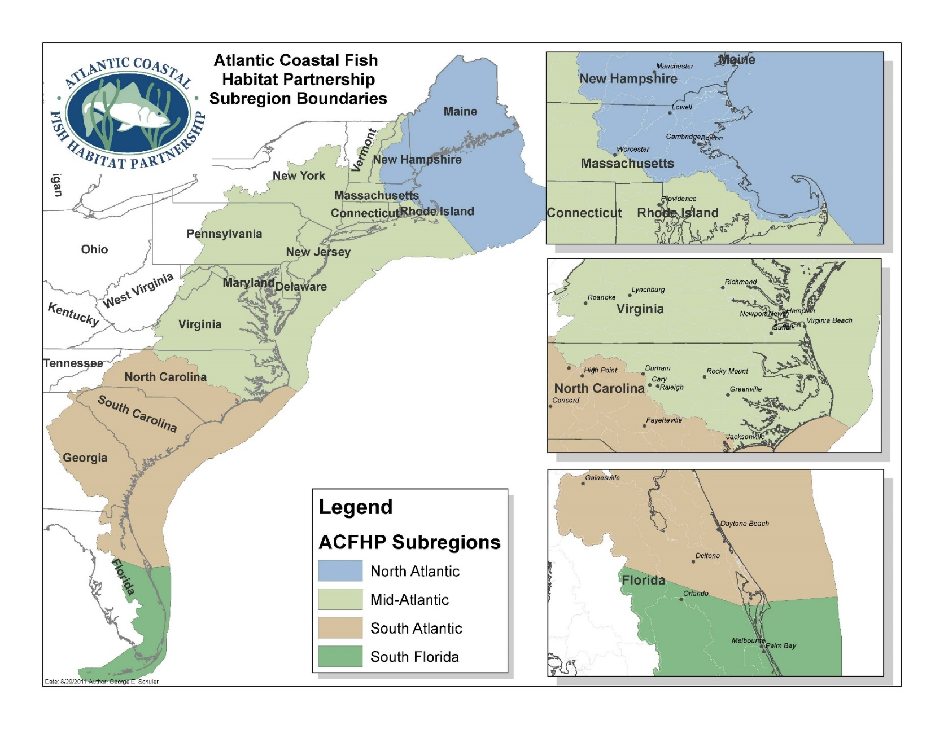**Appendix A. Atlantic Coastal Fish Habitat Partnership Subregional Boundaries: North Atlantic, Mid-Atlantic, South Atlantic, and South Florida**

**Appendix B: ACFHP Habitat Characterizations**

Note that the habitat category into which a habitat type falls is underlined.

**Marine and Estuarine Shellfish Beds**

**Oyster aggregations/reef**

Structures formed by the Eastern oyster (*Crassostrea virginica)* that provide the dominant structural component of the benthos, and whose accumulated mass provides significant vertical relief (> 0.5 m).

**Scallop beds**

Areas of dense aggregations of scallops on the ocean floor. Common Atlantic coast species include: (1) the large Atlantic sea scallop (*Placopecten magellanicus*), which ranges from Newfoundland to North Carolina; (2) the medium-sized Atlantic calico scallop(*Argopecten gibbus*), which is found in waters south of Delaware; and (3) the bay scallop (*Argopecten irradians)*,which occurs from Cape Cod to Florida, as well as in the Gulf of Mexico.

**Hard clam beds**

Dense aggregations of the hard clam (*Mercenaria mercenaria)* found in the subtidal regions of bays and estuaries to approximately 15 m in depth. Clams are generally found in mud flats and firm bottom areas consisting of sand or shell fragments.

**Shell accumulations**

Shells of dead mollusks sometimes accumulate in sufficient quantities to provide important habitat. Accumulations of Eastern oyster shells are a common feature in the intertidal zone of many southern estuaries.

**Coral and Live/Hard Bottom**

**Coral reefs**

Reef-building corals are of the order Scleractinia, in the class Anthozoa, of the phylum Cnidaria. Coral accumulations are restricted to warmer water regions, where the average monthly temperature exceeds 18°C (64°F) throughout the year. Through symbiosis with unicellular algae, reef-building corals are the source of primary production in reef communities.

**Patch reef, soft corals, or anemones**

A patch reef is an isolated, often circular, coral reef usually found within a lagoon or embayment. Soft corals are species of the anthozoan order Alcyonacea, of the subclass Octocorallia. In contrast to the hard or stony corals, most soft corals do not possess a massive external skeleton (e.g. sea pens and sea fans). Anemones are cnidarians of the class Anthozoa, that possesses a flexible cylindrical body and a central mouth surrounded by tentacles found in soft sediments.

**Live rock**

Calcareous rock that is removed from the vicinity of a coral reef with some of the life forms still living on it. These may include bacteria, coralline algae, sponges, worms, crustaceans, and other invertebrates.

**Macroalgae**

Large marine multi-cellular macroscopic algae (seaweeds). There are three types of macroalgae: green, brown, and red. Examples of macroalgae species found along the Atlantic coast include:

**Chlorophyta (green algae)**

*Ulva lactuca*, sea lettuce

**Phaeophyta (brown algae)**

*Fucus vesiculosus*, bladderwrack; *Laminaria* spp.; *Sargassum* spp.

**Rhodophyta (red algae)**

*Chondrus crispus*, Irish moss

**Submerged Aquatic Vegetation (SAV)**

SAV refers to rooted, vascular plants that live below the water surface in large meadows or small patches in coastal and estuarine waters. SAV can be further classified by the range of salinity of the waters in which they are found.

**Tidal fresh and oligohaline plant species**

Generally found in areas where salinity ranges from 0.5 to 5.0. Examples include:

*Vallisneria americana*, wild celery

*Ceratophyllum demersum*, coontail

**Mesohaline and polyhaline plant species**

Generally found in areas where salinity ranges from 5.0 up to 30. Examples include:

*Zostera marina*, eelgrass

*Ruppia maritima*, widgeon grass

**Tidal Vegetation**

**Estuarine emergent marsh**

Salt marsh is an environment in the coastal intertidal zone between land and brackish water. The low marsh zone floods twice daily, while the high marsh floods only during storms and unusually high tides. Smooth cordgrass (*Spartina alterniflora*) dominates the regularly flooded low marsh along much of the Atlantic coast. In addition, salt meadow cordgrass (*S. patens*), saltgrass (*Distichlis spicata*), and needle rush (*Juncus* spp.) species comprise much of the vegetative community of the mid to upper saltmarsh and brackish marsh.

**Tidal freshwater marsh**

Tidal freshwater marsh occurs where the average annual salinity is below 0.5. It is found along free-flowing coastal rivers, and is influenced twice daily by the incoming tides. Tidal freshwater marsh can be located just upstream of the salt front, where the river essentially backs up as it meets resistance from high tides. Tidal freshwater marsh is characterized by salt intolerant plant species. These include: giant cordgrass (*S. cynosuroides*), sawgrass (*Cladium jamaicense*), cattails (*Typha* spp.), arrow arum (*Peltandra virginica*), pickerelweed (*Pontedaria cordata*), blue flag (*Iris virginica*), and softstem bulrush (*Scirpus validus*).

**Mangrove**

The mangrove ecological community includes four tree species collectively called mangroves. This swamp system occurs along intertidal and supratidal shorelines in southern Florida. The four species found in Florida mangrove swamps are:

*Rhizophora mangle*, red mangrove

*Avicennia germinans*,black mangrove

*Laguncularia racemosa*, white mangrove

*Conocarpus erectus*, buttonwood

**Unvegetated Coastal Bottom**

**Loose fine bottom**

Submerged underwater bottom habitat in estuaries and oceans where the dominate sediment type is mud, silt, or sand.

**Loose coarse bottom**

Submerged underwater bottom habitat in estuaries and oceans where the dominant sediment type ranges from gravel to cobble.

**Firm hard bottom**

Submerged underwater bottom habitat in estuaries and oceans where embedded rock or boulders are the dominate sediment types.

**Structured sand habitat**

Linear, narrow sand features that develop where a stream or ocean current promotes deposition of sand.

**Riverine Bottom**

**Higher gradient headwater tributaries**

Streams in which the dominant substrate is comprised of gravel and cobble. The stream slope is greater than 2%. This characterization includes 1st to 3rd order streams[1].

**Moderate gradient tributaries**

Streams in which the dominant substrate is comprised of sand, gravel, and small cobble. The stream slope is between 0.51% and 2.0%. This characterization includes 1st to 3rd order streams.

**Moderate gradient large mainstem river coarser substrate**

Rivers in which the dominant substrate is sand, gravel, and cobble. The stream slope is between 0.51% and 2%. This characterization includes 4th order rivers and above.

**Moderate gradient large mainstem river finer substrate**

Rivers in which the dominant substrate is fine sediments (silt, mud, sand). The stream slope is between 0.51% and 2%. This characterization includes 4th order rivers and above.

**Low gradient coastal streams**

Generally low gradient 0% to 0.05% in slope. This characterization includes 1st to 3rd order streams located along the coast.

**Non-tidal freshwater mussel beds**

Freshwater mussel beds, located above tidal influence.

**Coastal headwater pond**

A pond connected to coastal streams and rivers, generally located near the headwaters.

**Non-tidal freshwater marsh**

A marsh that occurs in the non-tidal section along a river. The main feature of a freshwater marsh is its openness, with only low-growing or “emergent” plants. It may include grasses, rushes, reeds, typhas, sedges, and other herbaceous plants (possibly with low-growing woody plants) in a context of shallow water.

**Appendix C. ACFHP Habitat Conservation Objectives**

*On-The-Ground Implementation Objective 1*: Conserve and connect priority aquatic habitats to improve ecosystem function and increase climate resilience for fish, people, and nature.

*On-The-Ground Implementation Objective 2*: Collectively advance and elevate the work of ACFHP partners to support transformational conservation projects on priority habitats.

**Appendix D. NFHP Conservation Priorities**

* + - * 1. Conserve waters and habitats where all processes and functions are operating within their expected range or natural variation
        2. Conserve hydrologic conditions for fish
        3. Conserve physical and living habitats and features that support viable and sustainable species and/or populations in impacted or at-risk systems
        4. Reconnect fragmented fish habitats
        5. Conserve water quality for fish
        6. Support the structure and function of FHPs
        7. Enhance recreational, commercial, subsistence, and traditional fishing opportunities when conducting projects that conserve fish habitat

1. Strahler Stream Order is a hierarchical classification of streams. Headwaters are the first order, and two first order streams combine to form a second order stream. Two second order streams form a third order stream, and so on.